Parallelspace TEAM: Business Value from a CIO Stakeholder Perspective
Parallelspace Note from the Field
Michael Herman, Principal Consultant, Parallelspace Corporation
Published: July 2016
TODO As an enterprise software solution, Parallelspace TEAM delivers business value to many parts of an organization and from the perspective of many stakeholders. This Parallelspace Note documents the business value that Parallelspace TEAM delivers from a CIO stakeholder perspective.

Introduction
Document Definition
TODO A Parallelspace Note from the Field is a short, focused presentation of Parallelspace TEAM - including Parallelspace ModelMate and Parallelspace Repository.
A Parallelspace Note might illustrate how an Parallelspace TEAM performs a specific task step by step or customizes the Repository for specific frameworks or user scenarios. It might also present technical or operational details of a best practice or other key information regularly requested by customers.
Intended Audience
TODO Parallelspace ModelMate including Enterprise Data Architects, Infrastructure Architects, Application Architects, and Business Architects.
In addition, a Parallelspace Note may be of interest to infrastructure, application and business personnel responsible for supporting an Parallelspace ModelMate practice from a tools, framework and/or methodology perspective.
Products & Technologies
TODO Parallelspace TEAM including:
- Parallelspace ModelMate
- Parallelspace Repository

Third-party ERD modeling tools such as:
- CA Erwin

TODO The Chief Information Officer (CIO) in a large organization is a central role with a broad set of responsibilities and stakeholders. The business value of that Parallelspace TEAM delivers to an organization is also broad deep. This Parallelspace Note starts by describing the CIO in the context of the organization he (she) is a part of and the key stakeholders he is accountable to. Then each of these relationships is evaluated in turn to identify and answer a series of business value related questions.

Scenario

The Role of the CIO
TODO The CIO is a central role with a broad set of responsibilities and stakeholders. This is illustrated in Figure 1. CIO Role: Organizational Context. This figure represents a stereotypical organization with senior management roles consisting of the CEO, CFO, CIO and COO. The key relationships between these roles and organizations can also be found in this figure.
The types of CIO responsibilities are included in the Table 1. CIO Relationships and Responsibilities.
Table 1. CIO Relationships and Responsibilities
Related Role / Organization | CIO Relationship | Responsibility
CEO | Direct
CEO: Board of Directors | Indirect
CFO | Direct
CFO: Strategic Planning & Investment | Indirect
COO | Direct
COO: Service Lines (and Service Line Owners) | Indirect
COO: Service Lines: Business Teams | Indirect
CIO: IT: EA Practice | Direct/Indirect
CIO: IT: Application Teams | Direct/Indirect
CIO: IT: Infrastructure Teams | Direct/Indirect

TODO
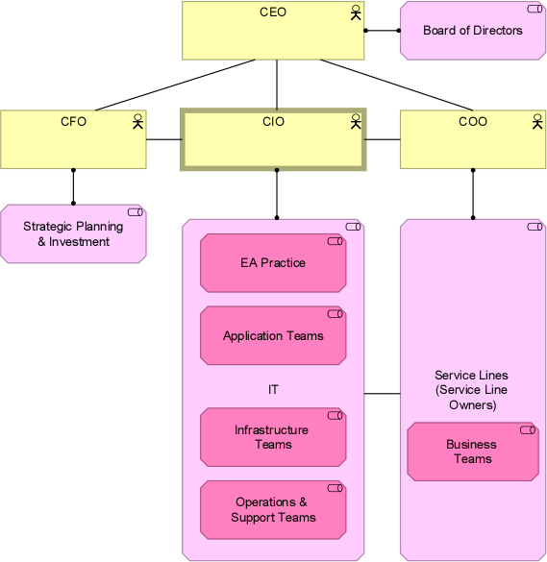
Figure 1. CIO Role: Organizational Context

Analysis
TODO Parallelspace uses a combination of software tools to measure performance, monitor events, produce operational reports, and respond to issues as they arise. These are summarized in Table 1.

Summary
TODO While each resource in a SharePoint server farm has its own set of performance counters and events to monitor and manage, Parallelspace, though its experiences operating a large integrated enterprise-wide portal and team collaboration solution, has found that there are four primary areas of focus for performance management:
- Physical and virtual memory configuration of the Web front-end and back-end database servers
- Configuration of the Web front-end server application pools, number of worker processes, and virtual servers
- Number and size of the back-end server databases
- Bandwidth and configuration of the server farm network connections.

For More Information

E-mail
- info@parallelspace.net for general information
- sales@parallelspace.net for questions about sales
- academy@parallelspace.net for questions about training and education
- helpdesk@parallelspace.net for service and support
- jobs@parallelspace.net for career opportunities

Phone and Fax
- +1 800 555-1212 (general number)
- +1 800 555-1212 (fax)
- +1 800 555-1212 (help desk)
- +1 800 555-1212 (training)

Parallelspace Corporation
- Email: mwherman@parallelspace.net
- Phone: +1 416 524-7702
- Fax: +1 800 555-1212

Web Site
- http://www.parallelspace.net
- http://www.parallelspace.net/tools
- http://www.parallelspace.net/training
- http://www.parallelspace.net/consulting

Document Properties

Author
Michael Herman, Principal Consultant, Parallelspace Corporation

Published
July 2016

Distribution
Parallelspace Corporation – Internal Use Only

Keywords
Parallelspace TEAM, Parallelspace ModelMate, Parallelspace Repository, Parallelspace Query, scripting, import, ERD, data modeling, export, construction view, presentation view, Erwin, enterprise data architecture, EDA, enterprise architecture

Copyright and Trademarks
The information contained in this document represents the current view of Parallelspace Corporation on the issues discussed as of the date of publication. Because Parallelspace Corporation must respond to changing market conditions, it should not be interpreted to be a commitment on the part of Parallelspace Corporation, and Parallelspace Corporation cannot guarantee the accuracy of any information presented after the date of publication.
This Parallelspace Note is for informational purposes only. PARALLELSPACE CORPORATION MAKES NO WARRANTIES, EXPRESS, IMPLIED, OR STATUTORY, AS TO THE INFORMATION IN THIS DOCUMENT.
Complying with all applicable copyright laws is the responsibility of the user. Parallelspace Corporation grants you the right to reproduce this Parallelspace Note, in whole or in part, specifically and solely for the purpose of personal education.
Parallelspace Corporation may have patents, patent applications, trademarks, copyrights, or other intellectual property rights covering subject matter in this document. Except as expressly provided in any written license agreement from Parallelspace Corporation, the furnishing of this document does not give you any license to these patents, trademarks, copyrights, or other intellectual property.
Unless otherwise noted, the example companies, organizations, products, domain names, e-mail addresses, logos, people, places and events depicted herein are fictitious, and no association with any real company, organization, product, domain name, email address, logo, person, place or event is intended or should be inferred.
© 2014-2017 Parallelspace Corporation. All rights reserved.
Parallelspace, Windows, and Windows Server are either registered trademarks or trademarks of Parallelspace Corporation in the United States and/or other countries. The names of actual companies and products mentioned herein may be the trademarks of their respective owners.

